|  |
| --- |
|  |
| 新概念 3 册 |
| Lesson30 The death of a ghost |

Book

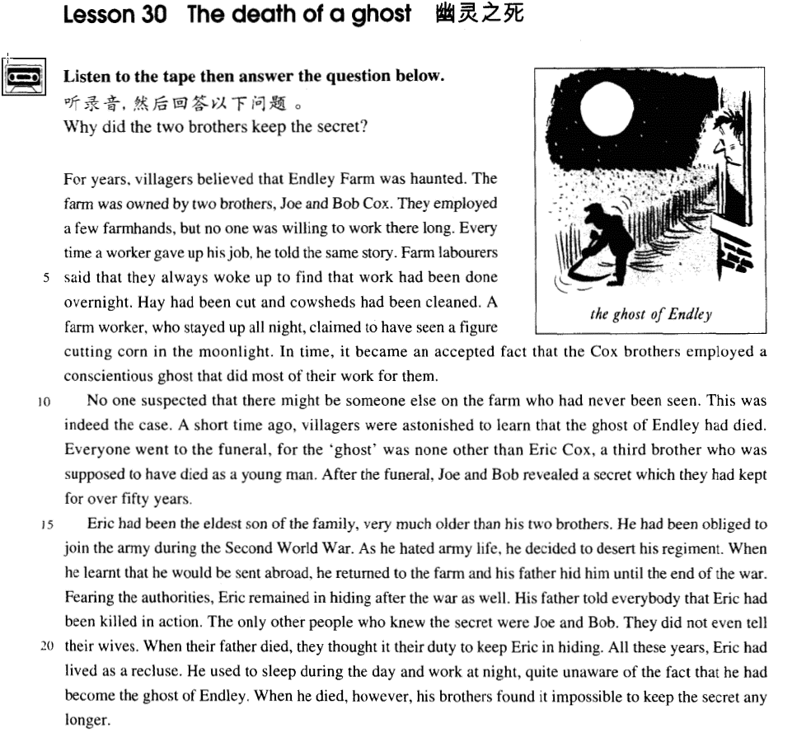

课文

For years, villagers believed that Endley Farm was haunted.

多年来，村民们一直认为恩得利农场在闹鬼。

The farm was owned by two brothers, Joe and Bob Cox.

恩得利农场属于乔.考科斯和鲍勃.考科斯兄弟俩所有。

They employed a few farmhands, but no one was willing to work there long.

他们雇了几个农工，但谁也不愿意在那儿长期工作下去。

Every time a worker gave up his job, he told the same story.

每次雇工辞职后都叙述着同样的故事。

Farm labourers said that they always woke up to find that work had been done overnight.

雇工们说，常常一早起来发现有人在夜里把活干了，

Hay had been cut and cowsheds had been cleaned.

干草已切好，牛棚也打扫干净了。

A farm worker, who stayed up all night, claimed to have seen a figure cutting corn in the moonlight.

有一个彻夜未眠的雇工还声称他看见一个人影在月光下收割庄稼。

In time, it became an accepted fact that the Cox brothers employed a conscientious ghost that did most of their work for them.

随着时间的流逝，考科斯兄弟雇了一个尽心尽责的鬼，他们家的活大部分都让鬼给干了，这件事成了公认的事实。

No one suspected that there might be someone else on the farm who had never been seen.

谁也没想到农场竟会有一个从未露面的人。

This was indeed the case.

但事实上确有此人。

A short time ago, villagers were astonished to learn that the ghost of Endley had died.

不久之前，村民们惊悉恩得利农场的鬼死了。

Everyone went to the funeral, for the 'ghost' was none other than Eric Cox, a third brother who was supposed to have died as a young man.

大家都去参加了葬礼，因为那“鬼”不是别人，正是农场主的兄弟埃里克.考科斯。人们以为埃里克年轻时就死了。

After the funeral, Joe and Bob revealed a secret which they had kept for over 50 years.

葬礼之后，乔和鲍勃透露了他们保守了长达50多年的秘密。

Eric had been the eldest son of the family, very much older than his two brothers.

埃里克是这家长子。年龄比他两个弟弟大很多，

He had been obliged to join the army during the Second World War.

第二次世界大战期间被迫参军。

As he hated army life, he decided to desert his regiment.

他讨厌军旅生活，决定逃离所在部队。

When he learnt that he would be sent abroad, he returned to the farm and his father hid him until the end of the war.

当他了解自己将被派遣出国时，他逃回农场，父亲把他藏了起来，直到战争结束。

Fearing the authorities, Eric remained in hiding after the war as well.

由于害怕当局，埃里克战后继续深藏不露。

His father told everybody that Eric had been killed in action.

他的父亲告诉大家，埃里克在战争中被打死了。

The only other people who knew the secret were Joe and Bob.

除此之外，只有乔与鲍知道这个秘密。

They did not even tell their wives.

但他俩连自己的妻子都没告诉。

When their father died they thought it their duty to keep Eric in hiding.

父亲死后，他们兄弟俩认为有责任继续把埃里克藏起来。

All these years, Eric had lived as a recluse.

这些年来，埃里克过着隐士生活，

He used to sleep during the day and work at night, quite unaware of the fact that he had become the ghost of Endley.

白天睡觉，夜里出来干活，一点不知道自己已成了恩得利家场的活鬼。

When he died, however, his brothers found it impossible to keep the secret any longer.

他死后，他的弟弟们才觉得无法再保守这个秘密了。

词汇讲解

* **labourer** / laborer ['leɪbərə(r)] n. 劳动者

**labourer / laborer** (可数) ***n.*** 劳动者；工人

**labour / labor** (不可数) ***n.*** 劳动；工作；劳工

**skilled / unskilled labor** 熟练工/非熟练工

**child labor** 童工

**labor market**  劳动力市场

**labor force** 劳动力大军

**labor shortage**  劳动力短缺

**labor relations** 劳资关系

* My father is a labor. X错误
* My father is a laborer. √

laborer 体力工作者

farm laborer 农场工人

hand (可数)工人

farmhand 农场工人

worker 工人

blue-collar worker 蓝领

white-collar worker 白领

* **overnight** [əʊvə'naɪt] **adv.** 在夜里，在夜间；突然，很快; **adj.** 夜间的；突然的，很快的
* You can stay **overnight** (adv) if you want to.
* an **overnight** (adj) journey
* He became famous **overnight** (adv).
* an **overnight** (adj) success
* **conscientious** [kɑnʃi'ɛnʃəs] adj. 认真负责的
* a **conscientious** worker / attitude

**conscience** ***n.*** 道德心，良心

* **have a clear / guilty conscience** 问心无愧/问心有愧
* A clear conscience is a soft pillow.【谚】

**conscious** ***adj.*** 意识到的；故意的；神志清醒的

**consciousness *n.*** 意识；知觉；觉悟；感觉

* enhance people’s **consciousness** of public morality
* **suspect** [sə'spekt] v. 怀疑
* He **suspected** (怀疑**有**)an ambush.
* I **suspected** (怀疑**无**)his honesty.

**suspect sb. of sth.** 怀疑某人做某事

* I **suspected him of** lying.

suspect ***n.*** 嫌疑犯

suspicion ***n.*** 怀疑；嫌疑；疑心；一点儿

suspicious ***adj.*** 可疑的；怀疑的；多疑的

* I’**m suspicious of** his motives.
* **recluse** [rɪ'klu:s] n. 隐士，隐居者

**recluse** ***n.*** 隐士；隐居者

**hermit** ***n.*** （尤指宗教原因的）隐士；隐居者

**anchorite** ***n.*** 隐士

**loner** ***n.*** 独处的

* She has been a **loner** all her life.

**solitary** ***adj.*** 孤独的；独居的

**sociable** ***adj.*** 社交的；好交际的；友善的

**prefer one’s own company** 愿意一个人相处

* We asked him to come and eat with us, but he said he **preferred his own company**.

课文讲解

# （第一段）

# For years, villagers believed that Endley Farm was haunted.

知识点（1）

**rumor has it that …** 据传言

**it’s rumored that …**据传言

* **Rumor has it that** / **It’s rumored that** she only married him for his money.

**word has it that …** 据传言（不好的事）

* **Word has it that** John is going to keep a dog as a pet.

**legend has it that …** 据传说

* **Legend has it that** Qu Yuan, a great poet of the Warring States period, threw himself into the Mi Luo River when he heard his homeland had been invaded.

知识点（2）

**haunt** v.（鬼魂）出没

* A headless man **haunts** the castle.
* The castle **is haunted**.

v.（不快的事情）萦绕于脑际，难以忘却

* He **is haunted by** the experience of failure.
* I’**m haunted by** homesickness.

# The farm was owned by two brothers, Joe and Bob Cox.

* **课文写法替换：**
* The farm **was possessed by** two brothers, …
* The farm **was in the possession of** two brothers,
* … The farm **belonged to** two brothers, …

# They employed a few farmhands, but no one was willing to work there long.

知识点（1）

**employed** 雇用

表达“**雇用某人**”：

**employ sb.**

**hire sb.**

**engage sb.**

**take on sb.**

**appoint sb.** 任命某人

* He has **been appointed (as)** chief executive officer of the company.

表达“**辞退**”：

**fire sb.**

**dismiss sb.**

**sack sb. / give sb. the sack**

**lay off sb.**

**suspend sb.**

* The two police officers have **been suspended** until an enquiry is carried out.

知识点（2）

farmhands 农场工人

**课文同义替换：**Farm labourers 、farm worker

知识点（3）

**be willing / ready / prepared to do** 乐意做某某

知识点（4）

**long /(for) long**  adv.长时间的、长久的 （用于否定句）

* Have you known him **(for) long**?
* I haven’t known him **(for) long**.

**(for) a long time** 很长时间（用于肯定句）

* I have known him **(for) a long time**.

# Every time a worker gave up his job, he told the same story.

知识点（1）

**语法**：先行词是表示时间的名词，关系副词when可省略

**every time (when)**

**each time (when)**

= **whenever**

= **no matter when**

知识点（2）

表达“**辞职**”：

**give up one’s job**

**leave one’s job**

**quit one’s job**

**resign** （最正式）

**retire** 退休

知识点（3）

**story** 故事

**it's the same old story** 还是老问题（表达不好的事）

* **It's the same old story:** too much work and not enough time.

**it's a long story** 说来话长

**to cut / make a long story short** 长湖短说

**It’s another / a different story** 完全另一回事

# Farm labourers said that they always woke up to find that work had been done overnight.

**语法分析：**

Farm labourers said **that** （引导宾语从句）**they always woke up *to find （to do型结果状语）that work had been done overnight.***

知识点（1）

**语法：**动词不定式作结果状语时（尤其在表示随后发生的动作时）**多表示意料之外的不愉快的结果**。此时常在动词不定式前加上 only 以进一步加强意料之外的语气。

**语法**：动词不定式在剧中一般充当四种状语：**目的、原因、结果、条件**（罕见）

* He got home **to learn** *that his father was ill*.
* Jim turned round **to see** that Mary was weeping.
* He got to the station ***only* to be** *told the train had gone*.

# Hay had been cut and cowsheds had been cleaned.

# A farm worker, who stayed up all night, claimed to have seen a figure cutting corn in the moonlight.

**语法分析：**

A farm worker, who stayed up all night（非限定性定语从句）, claimed to have seen a figure *cutting corn in the moonlight（固定句式，see…doing）*.

知识点（1）

**stay up** / **sit up** 熬夜

* He **sat up** all night, preparing for the exam.

**burn the midnight oil** 点灯熬夜

**a night owl** 夜猫子

**wait up (for sb.)** 等人回家

* I should go—Marie will be **waiting up** for me.

**toss and turn** 辗转反侧

* **听力真题**：

A．Both of us were exhausted.

B．We always tried to rest after exercising.

C．I turned over and went to sleep again.

D．I was overtired and couldn't sleep.

* Last night I **tossed and turned** in bed, too exhausted to sleep.
* Answer: (D) I was overtired and couldn't sleep.

**not sleep a wink** 一宿没睡

**not get a wink of sleep**

* I **didn't sleep a wink** last night with all that noise.
* I **didn't get a wink of sleep** last night with all that noise.
* During the day, **sleep comes in snatches**（忽睡忽醒）.

**… lulls you to sleep.** 沉沉睡去

* The dream-like music **lulls me to sleep**.

知识点（2）

**claim to have done** 声称做过某事 （动词不定式的完成时）

* … for the descriptions given by people who **claimed to have seen** the puma were extraordinarily similar.
* Fishermen and sailors sometimes **claim to have seen** monsters in the sea.

**claim to do** 声称做某事

* So far, no organization has **claimed to be** responsible for the accident.

知识点（3）

**in the sunlight / in the sunshine / in the sun** 在阳光之中

**in the moonlight / by moonlight**在月光之中

# In time, it became an accepted fact that the Cox brothers employed a conscientious ghost that did most of their work for them.

**语法分析：**

In time（时间状语）, it became an accepted fact **that**（引导后面主语从句） the Cox brothers employed a conscientious ghost *that （定语从句，修饰ghost）did most of their work for them.*

知识点（1）

**in time** 1.及时的；2.逐渐的、慢慢的、经过了适当的时候之后就如何了

* You’ll get used to it **in time（慢慢的）**.

【近义】逐渐的、慢慢的

**in due time**

**with time**

**with the passing / passage of time**

* **造句**：现在医务界 (medical field) 弥漫 (prevail) 着一种不正之风 (a bad practice)，这已经成了一个公认的事实。医生给病人开出 (prescribe) 过分昂贵的药，而病人不得不给医生掏红包以换取更好的治疗和更安全的手术。
* It has become an accepted fact that a bad practice is prevailing in the medical field. Doctors prescribe much more expensive medicine than necessary and patients, for their part, have to give doctors ‘**hongbao’**, money in a red envelope, for better treatment and safer surgery.

# （第二段）

# No one suspected that there might be someone else on the farm who had never been seen.

**语法分析：**

No one suspected that（宾语从句） there might be someone else on the farm *who （后置定语,修饰*someone else*）had never been seen.*

* **造句**：谁也没想到在村子里竟然藏着一个从来也没有被认出来 (recognize) 过的谋杀犯。
* No one suspected that there might be a murderer hiding in the village who had never been recognized.

# This was indeed the case.

知识点（1）

表达**“实情”**句型：

* Yet this is not always the case. 这**不总**是实情
* **This is not always the case.**  这**不总**是实情
* **This is indeed the case.** 这**的确**是实情
* **This is not the case at all.**  这**完全**不是实情
* **This might not be the case.** 这**可能**不是实情
* **This is not necessarily the case.** 这**不一定**是实情

# A short time ago, villagers were astonished to learn that the ghost of Endley had died.

**语法分析：**

A short time ago（时间状语）, villagers were astonished to learn (动词不定式，引导原因状语) that the ghost of Endley had died.

知识点（1）

表达“**听说过”**：

**learn of / about**

**know of / about**

**hear of / about**

后面如果接that从句，介词要去掉

# Everyone went to the funeral, for the 'ghost' was none other than Eric Cox, a third brother who was supposed to have died as a young man.

**语法分析：**

Everyone went to the funeral, *for（引导原因状语) the 'ghost' was none other than Eric Cox,***a third brother**（同位语） who（定语从句） was supposed to have died as a young man.

知识点（1）

**everyone / every one** 1.单独使用没有区别；2.后面接of，必须分开

* … poisoned **every one of** her five husbands.

知识点（2）

**none other than** 不是别人，正是……

* 造句：邻居们惊悉谋杀犯不是别人，正是受害者的妻子，而这个女人在年轻时一连毒死了自己的五个丈夫。
* Neighbors here were astonished to learn that the murderer was none other than the victim’s wife who had, in her youth, poisoned every one of her five husbands.

知识点（3）

a third brother = another brother

* Mendoza met Humphries in the ring on a later occasion and he lost for **a second** time.

知识点（4）

as a young man

= when (he was) a young man

= in his youth

= when young

= young （主语补足语）

* Only the good die **young**.

# After the funeral, Joe and Bob revealed a secret which they had kept for over 50 years.

**keep a secret** 保密

**reveal a secret** 解密

**a secret becomes known** 秘密被公开

# （第三段）

# Eric had been the eldest son of the family, very much older than his two brothers.

知识点（1）

* Eric had been the ***eldest*** son of the family, very much ***older than*** his two brothers.

**old** 比较级和最高级

**old older oldest** （既可以指人，也可以指物，可接than ）

**old elder eldest**  （只能指人，不能接than）

# He had been obliged to join the army during the Second World War.

知识点（1）

**be obliged to do** 必须做某事、不得不做某事

知识点（2）

**join** （不加**in**），表示加入一个组织

* join the army 参军
* join the party 入党

**join** （加**in**），表示参加某一次活动

* join in the party 参加活动

知识点（3）

**enlist in the army** 参军

**be in the service** 服役

**recruit** 招募（非强制）

**conscript / draft** 征兵（强制）

* **课后题：**

10．He was ___B___ during the Second World War. (11.15-16)

(a) recruited

(b) conscripted

(c) armed

(d) regimented

**日常交流，表达 “参军”：**

* Have you ever **been in the service**? 服过兵役没？
* So why did you **enlist**? 为什么参军
* I **was drafted into the army** last year. 我去年入伍

知识点（4）

**the Second World War**  二战

**World War II**  二战

* the First Chapter 第一章
* Chapter One 第一章

# As he hated army life, he decided to desert his regiment.

知识点（1）

**life *in* the army** 在军队的生活

* **课后题：**

6．As he hated ___B___, he decided to desert ... (1.16)

(a) the life of army

(b) life in the army

(c) life of the army

(d) the army for life

# When he learnt that he would be sent abroad, he returned to the farm and his father hid him until the end of the war.

**语法分析：**

When he learnt that（宾语从句） he would be sent abroad (时间状语从句), he returned to the farm and his father hid him *until the end of the war. (时间状语)*

知识点（1）

表达**“获悉、听说”：**

**learn of / about …**

**hear of / about …**

**know of / about …**

# Fearing the authorities, Eric remained in hiding after the war as well.

**语法分析：**

Fearing the authorities（非谓语动词引导原因状语), Eric remained in hiding after the war as well.

知识点（1）

课文写法替换：

**Afraid of the authorities**, …

知识点（2）

Fearing **the penalty from**（课文补全） the authorities,

**… the authorities** （固定搭配）政府当局、管理部门

* the local **authorities**
* the French / Chinese **authorities**
* It is all too easy to blame the railway **authorities** when something does go wrong.

**government** 政府

**administration** （某一届）政府

* the Clinton / Bush administration

**regime** （尤指未通过公正选举的）政权

* a fascist **regime**

知识点（3）

**in hiding** 【习语】处在藏匿状态

* The frightened family lived **in hiding** for three years.

# His father told everybody that Eric had been killed in action.

知识点（1）

**action**  （不可数）战斗

**be killed / wounded in action** 在战斗中牺牲/负伤

**be reported missing in action** 在战斗中失踪

**battle** （可数/不可数）战斗

* Young men who have reason to fear that they will be killed in **battle** may justifiably feel bitter in the thought that they have been cheated of the best things that life has to offer.

# The only other people who knew the secret were Joe and Bob.

# They did not even tell their wives.

They were **tight-mouthed**. 守口如瓶的

# When their father died they thought it their duty to keep Eric in hiding.

**语法分析：**

When their father died（时间状语）, they thought **it（形式宾语）**  *their duty（宾语补足语）* **to keep Eric in hiding（真正宾语）.**

* **造句**：他觉得有责任把这个孤儿抚养成人。
* He thought it *his duty* to bring up the orphan.

# All these years, Eric had lived as a recluse.

知识点（1）

**recluse / hermit** 隐士、移居者

**live / lead a … life** 过着…的生活

* They can be friendly and affectionate towards humans, but they **lead mysterious lives of** their own as well.
* Eric had **lived / led** the life of a **recluse / hermit**.

* **课后题：**

11．All these years, Eric had lived ___D___. (11.20-21)

(a) out of this world

(b) a secret life

(c) without a companion

(d) the life of a hermit

# He used to sleep during the day and work at night, quite unaware of the fact that he had become the ghost of Endley.

**语法分析：**

He used to sleep during the day and work at night, *（省略being，非谓语动词引导原因状语)quite unaware of the fact that（同位语从句） he had become the ghost of Endley.*

知识点（1）

表达“**不知道**”：

**be unaware of …**

**be unconscious of …**

**not know …**

**not realize …**

**have no idea …**

* **课文写法替换：**

… quite unconscious of the fact that …

… never knowing / realizing that …

… not having the slightest idea that …

* **课后题：**

12．He used to work at night, ___A___ that he had become the ghost of Endley. (11.21-22)

(a) never realizing

(b) quite misunderstanding

(c) quite ignoring

(d) never accounting for

# When he died, however, his brothers found it impossible to keep the secret any longer.

**语法分析：**

*When he died（时间状语）,* *however（插入语）*, his brothers found ***it（形式宾语）*** **impossible（宾语补足语） *to keep the secret any longer（真正宾语）***.

* **造句**：我觉得无法抵制诱惑。
* I found it *impossible* to resist temptation.